
(M2) Write a description of the communication methods and transmission media you are suggesting as the most suited to their needs with an explanation for your recommendations

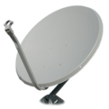





There are a number of options available for connecting networks together, they include:
(Describe which of these methods would be appropriate for connecting two nearby buildings together, it may be one, two or all)
Method | Description | Advantages
BT telephone connections
Infrared
Satellite
Direct cabling eg. Fibre optics

Summary: Which of these methods (it could be some or all) do you recommend be adopted and why do you consider these to be essential when connecting networks on different sites together

